# Debug Setup:

## Setup the command string

Figure – Configure the Command option for the excel.exe location

## Add the location of the dll to the Path:

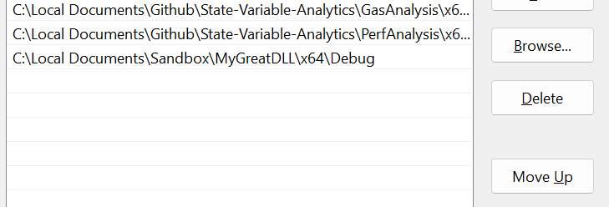

Figure – Adding the .dll location to the Path

## Add the location to Debug Environment:

